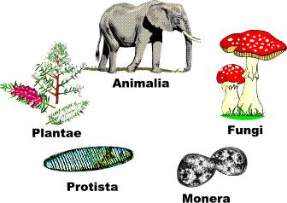
Apostrophe of Possession
Kingdom

Apostrophe of possession is used to show that the object belongs to someone or something. For example: Tom’s bicycle. The bicycle belongs to Tom. Or, the house’s roof needed repairing. The roof belongs to the house.

Choose the correct alternative:

1. Kingdoms/kingdom’s are/is the first level of classification.

2. The groups/group’s in kingdoms are/is quite large.

3. At the second level the kingdoms/kingdom’s are/is divided into phyla.

4. Animals/animal’s in the animal kingdom get their energy by feeding on other organisms.

5. Plants/plant’s in the plant kingdom can make their own food.

6. An animals/animal’s body are/is made of many cells.

7. Plants/plant’s are/is also made up of many/much cells.

8. Fungi cannot make their own food and must also feed on other organisms/organism’s.

9. A protists/protist’s main feature are/is that it is single-celled.

10. The kingdom Monera includes all the organisms/organism’s known as bacteria.

